Determining the Evolutionary Effect that Head Width has on Task Association in Different Species of *Formica* Ants

Evolution (BIOL 461)

30 March 2023

Nicole Kester

ABSTRACT

This paper specifically looks at the relationship between head width and task association in *Formica* ants. It was found that as the head width increases, the chances of getting assigned to nest building or protein foraging increases, while the likelihood of being assigned to honeydew collecting decreases. Mound-building and subterranean groups were tested in this study. Four of the six mound-building groups found that ants with smaller head widths were more commonly assigned to the honeydew collecting task rather than nest building or protein foraging. Subterranean groups were found to have a weaker size-task association and were smaller in size when compared to the mound-building group. These results support that head width could be an evolutionary change that has evolved in mound-building species of *Formica* ants in order to strengthen their colonies, and in turn produce more offspring.

INTRODUCTION

Task association based on body size has been studied in multiple different animal societies. Some species have discrete morphological worker subcastes which are used to help divide labor to protect the colony. Social insects such as thrips, aphids, termites, stingless bees, and some ants break into size-based morphs (Richards 2020). This allows smaller workers to be tasked with the less intense jobs, while the bigger workers take on tasks with more physical requirements. Task specialization allows workers to learn their specific task and avoid the cost of task switching, which is thought to increase efficiency of the colony (Chittka and Muller 2009; West 2022). Some may assume that insects without discrete subcastes would have less efficient colonies; however, in some cases where there is a high variance in worker size, it has been shown that there is still an association between worker size and task specialization (Grüter et al. 2011). This suggests that even if there are not specific subcastes, that some species still determine tasks assignments based on size.

There are over 15,100 species of ants (Hymenoptera: Formicidae) in the world (Wong and Guenard 2017). Looking at ants specifically, the genus *Formica* have a high level of natural worker size variation while lacking discrete morphological worker subcastes. This genus is found in North America, Europe, and Asia and are usually found in sparse to medium-dense mature forests, along the edges of the forest, or in ephemeral open patches (Sundström et al. 2005). Within this genus there are two groups: mound-building and subterranean. Mound-building species are facultative social parasites that build mounds on top of their underground nests. Subterranean species are not socially parasitic and they can sometimes build loose dirt mounds above their nests, but are usually entirely underground (Goryunov 2015).

Using a genus of ants with a high level of variation and lacking discrete subcastes allows us to test whether there is an association between task specialization and worker size. A study performed by Tawdros, West, and Purcell tested the relationship between body size and task assignment found both linear allometric and some isometric scaling. They log-transformed measurements and used linear models to assess the associations using five different measurements (Tawdros et al. 2020). Taking this a step further, we test whether head width measurements have an impact on task assignment, rather than looking at body size as a whole. The main goal of this paper is to determine whether there is an association between head width size and task across species of *Formica* ants.

MATERIALS AND METHODS

*Collection*

Data was collected in June-August of 2017 throughout Alberta, Canada. Ten species of *Formica* ants were observed and collected at ten different locations. There were three tasks that were focused on while collecting: honeydew collectors (HC), nest builders (NB), and protein foragers (PF). Honeydew collectors tend to aphids or other plants and they were selected while performing this task. Nest builders carry the materials to build the nests (pine needles, wood chips, dirt, pebbles) and then were selected while building the nest. Protein foragers search for prey and can be found carrying other insects or spiders (Tawdros et al. 2020).

*Head Measurements*

A Leica S8AP0 microscope with Leica DMC2900 camera attached to imaging software was used to photograph the head in 25x magnification. Measurements of each specimen were taken to one-thousandth of a millimeter measuring the widest point across the eyes with the Leica Application Suite version 4.6.2 (Tawdros et al. 2020; West 2022).

Figure : Example of head width

*Identifying Species*

Genetic sequencing (RADseq) was used to identify the species that had been captured. Two species in *F. rufa* group were unable to be identified so they are referred to as, ‘*F. rufa sp. #1*’ and ‘*F. rufa sp. #2*’. These species were separated into mound-building and subterranean groups. Mound-building groups included: *F. aserva, F. dakotensis, F. neorufibarbes, F. obscuricentris, F. ulkei,* and *F. rufa sp. #2.* The subterranean groups consisted of *F. glacialis, F. neoclara, F. podzolica,* and *F. rufa sp. #1* (West 2022) *.*

*Statistical Tests*

R Studio version 4.1.3 was used to evaluate data. A boxplot was made to demonstrate the relationship between head width and task for each species (Figures 1-11), as well as one with the total head widths and task assignments (Figure 12). The *nnet* package in R was used to perform a multinomial regression for head width and task association was performed under the assumptions that the model was specified correctly with no extraneous variables, the cases were independent of each other, and that there is no multicollinearity between the individual variables. The response level of each task was predicted using the ggeffects function in R. We specify that task be modeled as a function of head width. A logit model was made to demonstrate the ratio of the probability, or relative risk. A generalized linear model was performed using the *glm* function in R specifying head width as a function of task and group.

RESULTS

*Formica aserva, F. obscuriventris, F. ulkei, F. rufa sp. #1,* and *F. rufa sp. #2*, all show a statistically clear difference between ant head width of those selected for the honeydew collecting task when compared to the nest builders and protein foragers. *F. dakotensis, F. neorufibarbes*, *F. glacialis, F. neoclara*, and *F. podzolica* do not show any indications that head width is a determinant of task association. Overall, there is a relationship between head width and task association in five of the ten species that were tested with four of the seven belonging to the mound-building group (Figures 1-12).

Figure : Boxplot depicting relationship between head width and task in F. aserva.

Figure :Boxplot depicting relationship between head width and task in F. dakotensis.

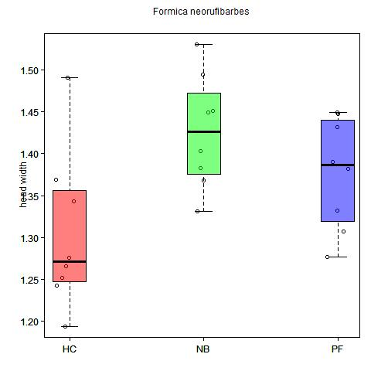

Figure : Boxplot depicting relationship between head width and task in F. neorufibarbes.

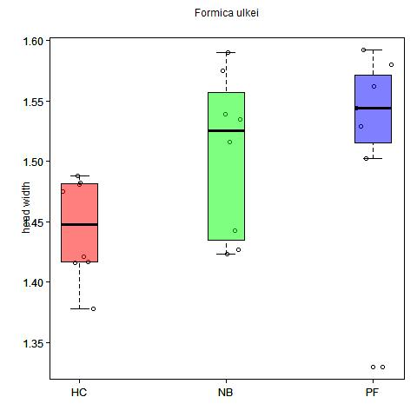

Figure :Boxplot depicting relationship between head width and task in F. ulkei.

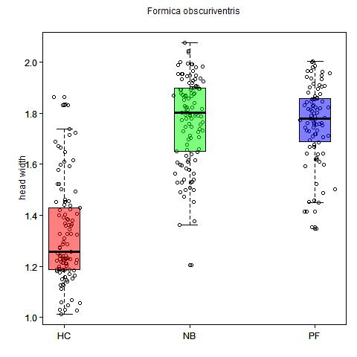

Figure :Boxplot depicting relationship between head width and task in F. obscuriventris.

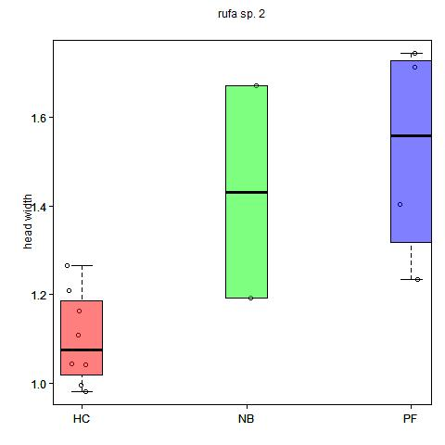

Figure :Boxplot depicting relationship between head width and task in F. rufa sp. #2.

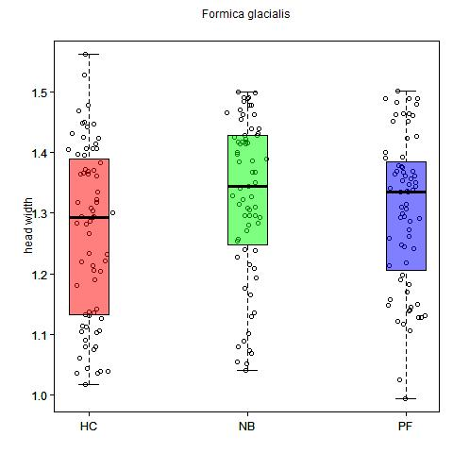

Figure : Boxplot depicting relationship between head width and task in F. glacialis.

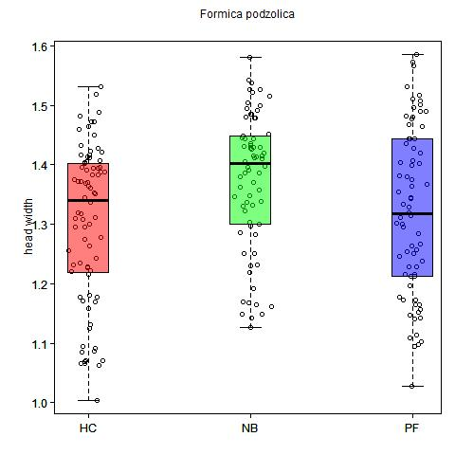

Figure : Boxplot depicting relationship between head width and task in F. podzolica.

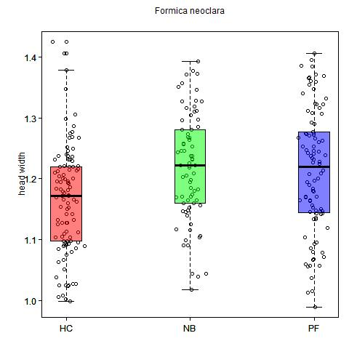

Figure : Boxplot depicting relationship between head width and task in F. neoclara.

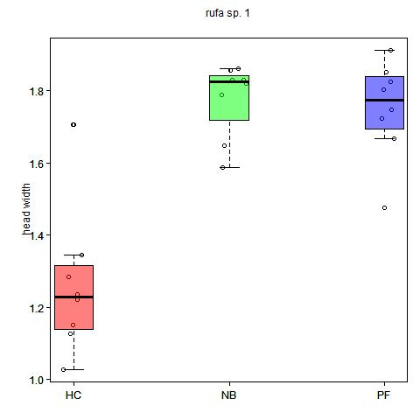

Figure : Boxplot depicting relationship between head width and task in F. rufa sp. #1.

Figure : Boxplot depicting the relationship between all head widths and task assignment.

The multinomial logistic regression using task as a function of head width found that the coefficient for NB to HC was 4.26 with a standard error of 0.35. The coefficient for PF to HC was 3.62 with a standard error of 0.35. The confidence intervals for NB was (3.57, 4.95), while PF was (2.94, 4.31). There was a total of 454 collections for HC, 515 for NB, and 515 for PF. Figure 13 was created to depict the predicted probability of each task with the ribbons showing the lower and upper confidence limits.

Table : Table showing data found via multinomial logistic regression using task as a function of head width.

|  |  |  |  |
| --- | --- | --- | --- |
| Task | Coefficient | Standard Error | Confidence Interval |
| NB-HC | 4.26 | 0.35 | (3.57, 4.95) |
| PF-HC | 3.62 | 0.35 | (2.94, 4.31) |

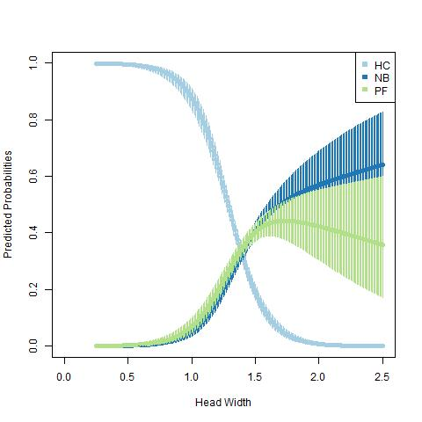

Figure : Graph showing the predicted values of which task will be selected depending on head width with ribbons showing the lower and upper confidence limits.

The generalized linear model found that for an ant with head width of 1.32, then 0.36 would be added if it was from either NB or PF task. If it was part of the subterranean group, then 0.9 would be subtracted from the head width. If the ant was assigned to the NB task and was also part of the subterranean group, then 0.28 would be subtracted. Whereas if the ant was assigned to the PF task and was also part of the subterranean group then 0.31 would be subtracted.

Table : Generalized linear model showing the results of head width as a function of task and group.

|  |  |  |
| --- | --- | --- |
|  | Estimate | Standard Error |
| Value | 1.32 | 0.013 |
| Task NB | 0.36 | 0.018 |
| Task PF | 0.36 | 0.019 |
| Group Subterranean | -0.09 | 0.017 |
| Task NB: Subterranean | -0.28 | 0.024 |
| Task PF: Subterranean | -0.31 | 0.025 |

DISCUSSION

The outliers in the head widths within each task makes it difficult to accurately assess the size-task association of the *Formica* ants on the boxplots, but by looking at the interquartile range it is easier to see the differences in size-task association. If the error bars do not overlap then there is a significant difference between the tasks. The values depicted in the boxplots seem to follow the trend that mound-building species have a stronger association between the ants with smaller head widths being assigned to the honeydew collecting task (Figures 1-12). Since mound-building requires carrying larger loads to build the mounds, the ants with larger heads could be assigned to the more physically demanding jobs to make them more efficient. Whereas, in the subterranean groups this would not be necessary. The association in *F. dakotensis* and *F. neorufibarbes* were not as strong as the relationship found in the other mound-building species. This could be due to the variance in sampling size impacting the quality of data necessary to draw conclusions. Another possibility would be that these species did not build as big of mounds as the other species, so ants with smaller heads could still complete the task. Likely the most possible explanation would be that head width specifically may not be the determinate of task assignment in those species or in the subterranean groups.

The coefficients for the relative risk of task and head width found that PF and HC both have a standard error of 0.35, the larger coefficient in the NB means that with each additional increase in head width the log odds of choosing NB is 4.26 chances higher, while the log odds of choosing PF is 3.62 chances higher than choosing HC. Figure 13 shows the predicted values of a certain task being selected based on head width with upper and lower confidence levels. This shows that HC has a much higher chance of being assigned if the head width is small compared to NB or PF.

The generalized linear model further shows that if the ant is in a subterranean group rather than a mound-building group then it will likely be smaller overall as well as having less of a relationship between task associations. When comparing the two groups it shows that 0.9 should be subtracted if it is in the subterranean group, which suggests that overall any ants in those groups are smaller than those in the mound-building groups. Both of the tasks in the subterranean group are also negative which further supports that the group is smaller. It also shows that the relationship is not as strong since NB only changes by 0.28 and PF changes by 0.31; while in the mound-building groups they both change by 0.36. This shows that the mound-building groups are larger than ants in subterranean groups and that there is a stronger relationship in size-task associations.

REFERENCES

Chittka, L., and H. Muller. 2009. Learning, specialization, efficiency and task allocation in social insects.

Goryunov, D. N. 2015. Nest-building in ants Formica exsecta (Hymenoptera, Formicidae). Entmol. Rev. 95:953–958.

Grüter, C., C. Menezes, V. Imperatriz-Fonseca, and F. Ratnieks. 2011. A morphologically specialized soldier caste improves colony defense in a neotropical eusocial bee.

Richards, M. H. 2020. Size and shape in Formica ant workers. Insect. Soc. 67:457–458.

Sundström, L., P. Seppä, and P. Pamilo. 2005. Genetic population structure and dispersal patterns in Formica ants — a review. Annales Zoologici Fennici 42:163–177. Finnish Zoological and Botanical Publishing Board.

Tawdros, S., M. West, and J. Purcell. 2020. Scaling relationships in Formica ants with continuous worker size variation. Insect. Soc. 67:463–472.

West, M. 2022. A Cross-Species Comparison of Task Partitioning in Ants Lacking Discrete Morphological Worker Subcastes. UC Riverside.

Wong, M. K. L., and B. Guenard. 2017. Subterranean ants: summary and perspectives on field sampling methods, with notes on diversity and ecology (Hymenoptera: Formicidae).